**MPLS Lab - Group 7 - CSC/ECE576**

**Nishant Karajikar, Yuri Kolesnikov, and Nikhil Khatu**

**Question 1:**

**Label tree for Subnet- 10.0.4.0 255.255.255.0 :**

|  |  |  |  |  |
| --- | --- | --- | --- | --- |
| **LFIB** | **Incoming Label** | **Outgoing Label** | **Next Hop** | **Outgoing Interface** |
| R10 | 22 | 17 | 10.0.1.2 | g 1/0 |
| R11 | 17 | 17 | 10.0.2.2 | g 2/0 |
| R12 | 17 | 0 | 10.0.4.1 | g 2/0 |
| R13 | 0 | - | - | - |
| R15 | 18 | 0 | 10.0.5.2 | g 1/0 |
| R16 | 20 | 18 | 10.0.6.2 | g 1/0 |
| R17 | 22 | 20 | 10.0.7.2 | g 1/0 |

**Why do you think labels are 0?**

The outgoing labels from R12 and R15 are '0' to signal R13 that it doesn't need to label switch the packet and it doesn't need to do the initial LFIB lookup(used in PHP). Additionally, the 0 signifies the use of “explicit null.” This means that R13 should retain the EXP priority bits from the MPLS header to preserve QoS functionality.

**What is Penultimate Hop Popping?**

PHP is used by the second from the last LSR to signal to the LSR that it is the last label switched node; I.e this last LSR should remove the MPLS header and packet switch to the destination network without a LFIB lookup.

**Question 2:**

LDP Hello:

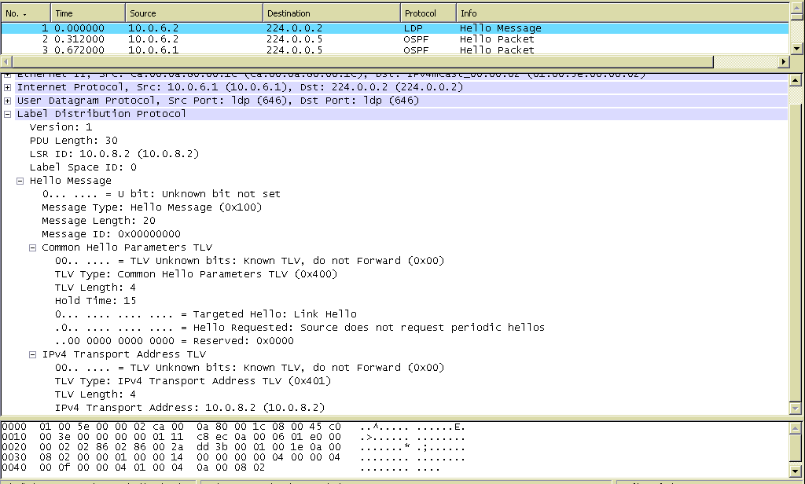

**What is the destination IP address and port# of the Hello message?**

Destination IP: 224.0.0.2

Destination port #: 646

**Which transport protocol is used?**

User Datagram Protocol

**What is the contents of the “LDP id” field in the LDP header?**

Label space ID: '0'

LSR ID: 10.0.8.2

**Is the message a “Link Hello” or a “Targeted Hello”?**

This message is a Link Hello since the Destination IP address is 224.0.0.2. This is the multi-cast address to deliver to all routers in a network.

**Are periodic targeted hellos requested from the receiver of the message?**

The receiver of this message is R15 on interface 10.0.6.2.

By checking the followed LDP message from 10.0.6.2 we find that periodic hellos are not required: “Source does not request Periodic Hellos.”

**For how long will the sender retain records of Hellos received from other LSRs? Why?**

The records of Hellos are retained for 15 seconds. This is indicated in the Hold time section of the hello parameters TLV and is the default value for link hellos.

**Label Mapping Message:**

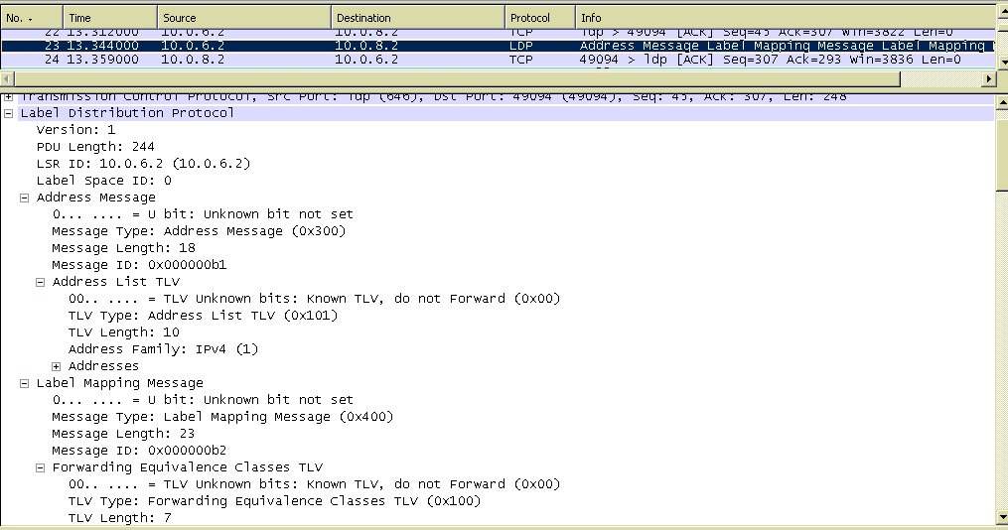

**Are there any other LDP messages in the PDU? If yes, what are they and what is their purpose?**

Yes, each of these embedded LDP messages correspond to one FEC and its assigned label(wrt the advertising LSR's).

**The Label Mapping message advertises a label-FEC binding to the LDP peers of the sender. It contains two TLVs – what are they?**

The two TLVs are the FEC and the label assigned to the FEC(wrt to the sender)

**What is the label-FEC binding advertised by this message?**

10.0.7.0 – Label 0

10.0.8.0 – Label 0

10.0.5.0 – Label 16

10.0.2.0 – Label 17

10.0.1.0 – Label 18

10.0.3.0 – Label 19

10.0.4.0 – Label 20

10.0.6.0 – Label 0

The source address is 10.0.8.2. We can see that networks 10.0.7.0, 10.0.8.0, and 10.0.6.0 are directly connected; therefore a label of 0 is used to transmit to the next LSR destined to these networks.

**Question 3:**

*R10#traceroute 10.99.99.16*

*Type escape sequence to abort.*

*Tracing the route to 10.99.99.16*

*1 10.0.1.2 [MPLS: Label 25 Exp 0] 180 msec 168 msec 204 msec*

*2 10.0.3.2 [MPLS: Labels 28/25 Exp 0] 176 msec 200 msec 180 msec*

*3 10.0.4.2 [MPLS: Labels 28/25 Exp 0] 188 msec 172 msec 188 msec*

*4 10.0.5.2 [MPLS: Label 25 Exp 0] 196 msec 192 msec 184 msec*

*5 10.0.6.2 172 msec 188 msec \**

*R10#traceroute 10.99.99.17*

*Type escape sequence to abort.*

*Tracing the route to 10.99.99.17*

*1 10.0.1.2 [MPLS: Label 26 Exp 0] 188 msec 196 msec 164 msec*

*2 10.0.3.2 [MPLS: Labels 28/26 Exp 0] 156 msec 188 msec 180 msec*

*3 10.0.4.2 [MPLS: Labels 28/26 Exp 0] 176 msec 172 msec 184 msec*

*4 10.0.5.2 [MPLS: Label 26 Exp 0] 172 msec 216 msec 168 msec*

*5 10.0.7.2 160 msec 212 msec \**

**What labels are used when tracing 10.99.99.16 and 10.99.99.17?**

When tracing to R16 label # 25 is used by LSRs not in the tunnel while label 28 is used for the tunnel.

When tracing to R17 label # 26 is used by LSRs not in the tunnel while label 28 is used for the tunnel.

**Which of the two labels was added by the tunnel?**

In both cases label # 28 is added by the tunnel.

**Based on the output of traceroute, where is the tunnel label popped?**

Based on the traceroute output the tunnel label is popped by R14 due to PHP.

**Where are the inner labels popped? Why?**

The inner labels are popped at R15 since we are using PHP implicit-null.

**Question 4:**

**Packet Capture of traceroute on Link R12 to R13 indicates two MPLS headers.**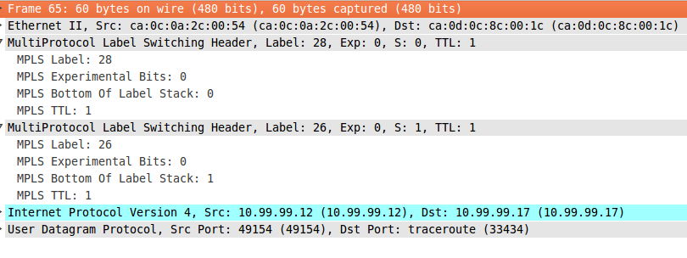

**Do the label values match those you've seen earlier in the output of traceroute?**

Yes, the labels 28/26 are the same as in the traceroute to 10.99.99.17

**What is the value of the “bottom of label stack” field in each of the headers? What does this field mean?**

The “bottom of the label stack” field has the values of ‘0’ and ‘1’, respectively.

This field basically denotes whether or not the last entry in the label stack has been reached. ‘1’ signifies the end of the label stack.

**Find a message that was actually used to reserve the label of one of the tunnels.**

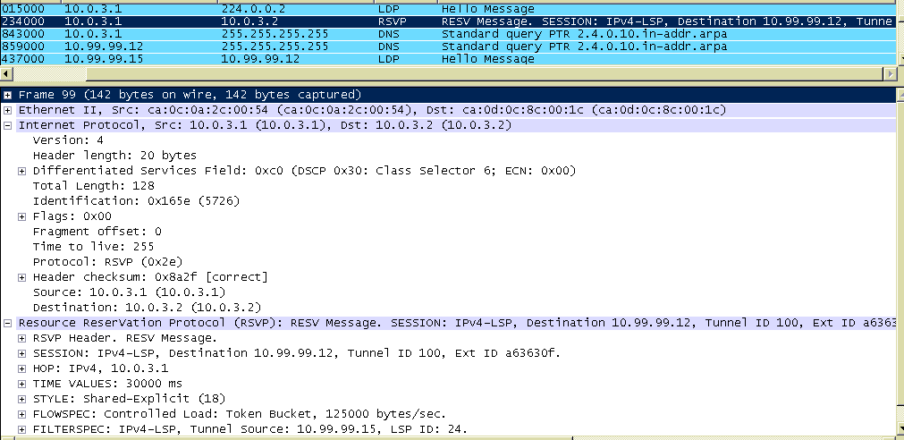

**Are the RSVP-TE messages routed over MPLS?**

No, RSVP-TE messages aren’t routed over MPLS. They are sent in raw IP datagrams without either a UDP or a TCP encapsulation.

**What is the destination of the RSVP session?**

Destination IP address = 10.99.99.12

**What is the “tunnel ID” defined in the SESSION object?**

Tunnel ID = 100

**What is the refresh interval?**

The “Time Values” field holds the value of the refresh interval. In this case, it is 30000ms.

**What is the reservation style?**

The reservation style is ‘Shared Explicit’.

**Now look at the FLOWSPEC object in the message. What type of IntServ service was requested?**

In this case, the type of IntServ service requested is “Controlled Load”.

**What are the reserved data rates?**

125000 bytes/sec indicated in wireshark

= 125,000 * 8 -> 1000 Kbit/sec

*!*

*interface Tunnel100*

*ip unnumbered Loopback0*

*mpls ip*

*tunnel destination 10.99.99.12*

*tunnel mode mpls traffic-eng*

*tunnel mpls traffic-eng autoroute announce*

*tunnel mpls traffic-eng priority 7 7*

*tunnel mpls traffic-eng bandwidth 1000*

*tunnel mpls traffic-eng path-option 10 dynamic*

*no routing dynamic*

*!*

**Do they match the ones we specified earlier when setting up the tunnel interfaces in Cisco IOS?**

Yes, the RSVP message datarates match the 1000Kbps rate specified in the lab.